Formatting a Spreadsheet
Create the following spreadsheet EXACTLY as shown below and make sure it is formatted in the same way.
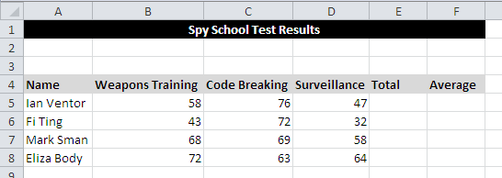
Complete the spreadsheet by typing in the formula: in E5 add together B5, C5 and D5.
To use this formula for the other cells click on E5, hover your mouse on the square in the bottom right corner of the cell and hold down the mouse button. Drag this down to E8 and release the mouse button. This is called AutoFill.
Click on this square and drag it down to E8 to AutoFill the formula.
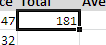
In F5 type in a formula to divide E5 by 3. AutoFill this down to cell F8.
Highlight cells F5 to F8 and change the numbers to have 2 decimal places by experimenting with the following buttons:
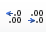
Save the spreadsheet with the name Test Results in your work area.

