Conditional Formatting
Make sure you have the Test Results spreadsheet that you created open on the screen. It should look as follows:
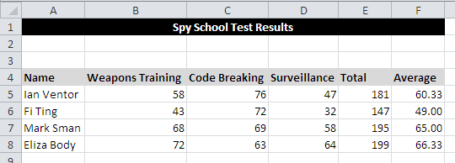
If the cells contain a value under 50 then they need to be shown in red and if they are over 50 then they need to be shown in green. We are going to use Conditional Formatting to do this automatically.
Highlight cells B5 to D8 and click on the Conditional Formatting button:
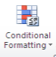
Select the Highlight Cells Rules option from the drop down list and then select the Less Than option from the second list.
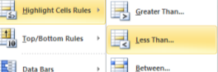
In the Less Than box that appears enter the following data then click on OK.
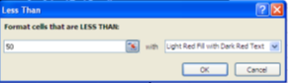
Now format cells B5 to D8 so that if it contains a value OVER 50 it will turn green.
Save your spreadsheet.

