Functions Homework
Name: |  | Class:
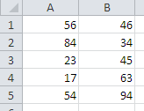
Task 1: Look at the spreadsheet above and write the correct formulae or functions into the table below:
Question | Answer
- What is the formula to add up A1 and B1?
- What is the formula to work out A2 take away B2?
- What is the formula to multiply A3 by B3?
- What is the formula to divide A4 by B4?
- What is the function to add up A1 to B5?
- What is the function to find out the average of A1 to B5?
- What is the function to find out the lowest number in cells A1 to B5?
- What is the function to find out the highest number in cells A1 to B5?
Extension Activity: Use the space below to explain the difference between a formula and a function.

