American style pancakes

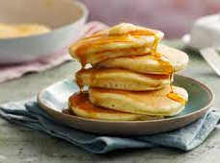
Ingredients:
150g self-raising flour
½ tsp baking powder
2 tsp caster sugar
1 medium egg
150ml milk
Pinch of salt
1tbsp vegetable/sunflower oil

Method:
1. Using your jug, measure out 150ml of milk.
2. Carefully crack the egg into the milk.
3. Add the dry ingredients (flour, sugar, baking powder and salt) to the jug and beat together until a thick, smooth batter is created.
4. Lightly coat a non-stick frying pan with oil, heat the pan on a medium-high heat (6 should do it). Allow the pan to heat up for 30 – 60 seconds before adding any mixture.
5. Use the jug to pour the mixture into the pan to your desired pancake size, use the back of a spoon to level off/flatten as required.
6. Wait for bubbles to appear on the surface of your pancake and then begin to pop (this should take around 60 seconds.
7. Use a palette knife to check the bottom has cooked sufficiently before carefully lifting and flipping the pancake over.
8. Cook on the opposite side for approx. two minutes until the pancake is fully cooked throughout.

Top tips:
- Leave enough space between your pancakes to avoid them sticking together in the pan.
- Remember that the bigger they are, the harder they are to flip and cook correctly.
- You may need to turn down the hob if the pancakes start to burn/cook too quickly on the outside leaving a raw centre.

