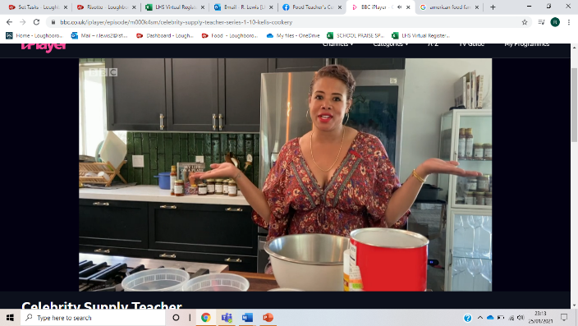**Celebrity Supply Teacher: Week 2**

**Click**: <https://www.bbc.co.uk/iplayer/episode/m000k4sm/celebrity-supply-teacher-series-1-10-kelis-cookery>

**Or google:** ‘celebrity supply teacher series 1:10’

**Task 1**:

Watch this week’s episode of Celebrity Supply Teacher and attempt to answer the questions below.

Keep a look out for the ingredients and method, as you’ll need this for Task 2 on the next page! You will probably need to pause it a few times.

1. Who was this week celebrity supply food teacher?
2. What is she making?
3. Which country does this this food come from?
4. (a) What is the surprise ingredient she adds to the mix?

(b) Why does she say she adds this surprising ingredient?

1. (a) What other foods are described as being from the same country?

(b) Can you think of any other foods that are famous from that country?

1. (a) What does the celebrity chef call what we in the UK call ‘plain flour’?
2. What is a more common name for corn meal in this country? (google this one!)

**Task 2:**

Write up a recipe sheet for the recipe featured in the episode. You will need to stop and pause the video.

(if you are you are typing up you answers, delete the lines provided)

**Recipe:**

**Ingredients:**

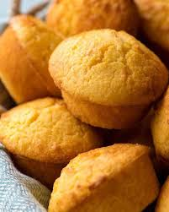

**Method:**



**Task 3:**

Plan an American themed restaurant menu. Include the name of the dish and a brief description below it. Try to include at least 6 options, including both savoury and sweet options. Use the internet to research American food and try to include one or two things you haven’t heard of/tried before e.g. gumbo, clam chowder