The aim of today’s lesson is to develop your knowledge of food science and to design your own Ice Cream sundae.

Answer the following questions by typing in your answers below each questions

**Task 1**: Watch the following video/programme which is 10 minutes long

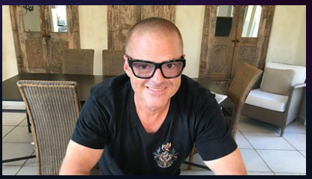

**Google search:** ‘*Heston supply teacher’* or follow this [link](https://www.bbc.co.uk/iplayer/episode/m000jybb/celebrity-supply-teacher-series-1-5-heston-blumenthal-food-science) – on BBC iPlayer, tick the box saying you do have a TV license

1. Name the celebrity chef
2. What is the difference between taste and flavour?

Taste =

Flavour =

1. Which two ingredients did Heston add to his ice cream Sundae?
2. What is the name for fruit sugar?
3. Identify four pieces of kitchen equipment you saw Heston use in his cooking

i)

ii)

iii)

iv)

1. How did Heston make the Olive Tapenade ?
2. Instead of using a tea towel or cloth to handle the hot bowl what would you use instead and why?
3. How long did the strawberries fry for in the frying pan?
4. If you are not a vegetable lover, how was it suggested that you could introduce vegetables into your diet?
5. A chocolate brownie is not very gooey, give two reasons why this may be the case

i)

ii)

1. Identify one new piece of information you have learnt today by watching the programme

**Task 2 ( this has been uploaded to the assignment on google classroom separately)**

On a separate piece of blank paper, design your own ice cream sundae. Include something out of the ordinary or uncommon that you would not expect to see in a pudding, but might work well. Draw and annotate (label with description). Use the whole page and colours if you have them (shading if not).

**Task 3:** Celebrity chef research (Heston might be an interesting one)

Create a fact file page about a celebrity chef of your choosing. Find out as much as you can about them e.g. where they are from, what style of food they are known for, what restaurants they have worked at, what TV shows they are on/have been on.

Find some recipes of theirs that take your fancy, either because you’d really like to eat them, or because they are interesting/less familiar/impressive to look at etc. Include pictures if you can.